

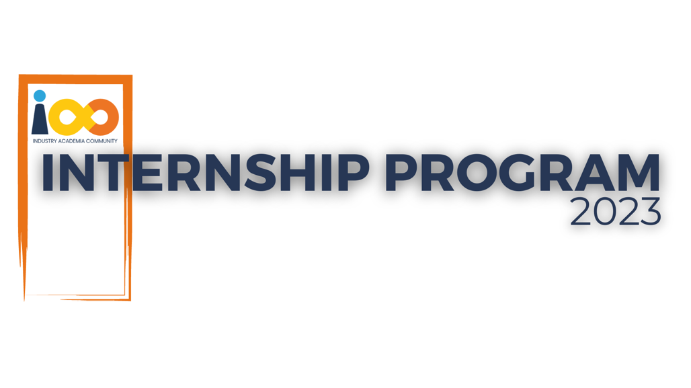

PROJECT REPORT

Machine Learning  
  
Student Graduation Year and Placement Prediction

|  |  |  |  |
| --- | --- | --- | --- |
| **Created By:** | Putti Chaitanya Phaniswar | **Approved By:** | <Domain Lead Name> |
| **Created On:** | 23-09-23 | **Approved On:** | DD-MMM-YYYY |

Page left blank intentionally

**INDEX**

**1** **PROJECT DETAILS** 2

**2** **SUMMARY** 2

**3** **INTRODUCTION** 2

3.1 Background 2

3.2 Stakeholders 2

3.3 Objectives 2

**4** **METHODOLOGY** 2

4.1 Considerations & Assumption 3

4.2 Approach 3

4.3 Activities 3

**5** **TARGETTED V/S ACHIEVED OUTPUT** 3

**6** **CONCLUSION** 3

**7** **APPENDICES** 4

7.1 Appendix A – Title 4

**General Instructions for using the Live Project Report Template**

* This template and the subsequent document created using this template is a confidential document and is the intellectual property of Cloud Counselage Pvt. Ltd. Circulating it outside of the organisation without the consent of Cloud Counselage Pvt. Ltd. is the breach of company policies and will lead to legal actions
* This template is a guideline document to communicate the implementation of design ideas and the results of the work to the stakeholders.
* The **text between inequality (< >) is to be replaced** by relevant text
* Please **remove the yellow highlight on the Text** between the inequality (< >). This is done to help you notice the text to be changed/replaced
* The text in *italics* highlighted in grey is just for reference and should be removed after adding the relevant text

# **PROJECT DETAILS**

|  |  |  |  |
| --- | --- | --- | --- |
| **Project Name** | Student Graduation Year and Placement Prediction | | |
| **Project Sponsor** |  | | |
| **Project Manager** |  | | |
| **Start Date** | 17-08-23 | **Completion Date** | 30-09-23 |

# **SUMMARY**

**Project Summary:**

The "Student Graduation Year and Placement Prediction Project" is an initiative undertaken by Cloud Counselage to address the challenges faced by students in understanding their academic progression and future career prospects. The primary objective of this project is to develop a predictive model that accurately estimates students' expected graduation years and predicts their placement outcomes.

**Relevance:**

The project directly impacts students' academic performance and future work prospects.

It aims to reduce postponed graduations, unemployment rates, and limitations in professional development.

# **INTRODUCTION**

## Background

Students often lack clear guidance and career advice, leading to uncertainty about when they will graduate and whether they will secure a job placement.

This uncertainty can result in delayed coursework completion and unpreparedness for the job market, impacting career prospects.

## Stakeholders

<Type Here>

## Objectives

Develop a predictive model for estimating students' graduation years with high accuracy.

Create a model for predicting students' placement outcomes based on academic records, course progress, extracurricular activities, and past placement results.

# **METHODOLOGY**

These conventions are all about the positions of line breaks, how many characters should go on a line, and everything in between.

## Considerations & Assumption

1. **Data Availability:** It is assumed that relevant data, including student academic records, course progress, extracurricular activities, and past placement results, will be available and accessible for model training and prediction.
2. **Data Quality:** It is assumed that the data provided for model training is accurate, complete, and up-to-date. Inaccurate or incomplete data could affect the accuracy of predictions.
3. **Access to Necessary Tools:** The project assumes access to suitable machine learning libraries, data processing tools, and development environments (e.g., Python, Jupyter Notebook, or similar tools) to implement the predictive models.
4. **Stakeholder Cooperation:** The project assumes cooperation and engagement from stakeholders, including educational institutions, students, and employers, to collect and share relevant data.
5. **No Major Regulatory Changes:** It is assumed that there will be no significant changes in regulatory or legal requirements that could impact data access, usage, or the implementation of predictive models.
6. **Stable Technology Environment:** The project assumes a stable technology environment, including dependable internet access and the availability of required software and hardware resources.
7. **Model Generalization:** The machine learning models are assumed to generalize well to predict graduation years and placement outcomes for a diverse range of students.
8. **Acceptance of Predictions:** It is assumed that students and educational institutions will accept and utilize the predictions provided by the system to make informed decisions.
9. **Availability of Expertise:** Skilled data scientists or machine learning experts are assumed to be available to develop, train, and fine-tune the predictive models.
10. **Budget and Resources:** Sufficient budget and resources are assumed to be available to support the development, testing, and deployment of the project.
11. **Security and Privacy:** Adequate measures for data security and privacy protection are assumed to be in place to safeguard sensitive student information.

It's important to document these assumptions in the project plan and regularly review them to identify any potential risks or changes that may affect the project's progress. Additionally, contingency plans should be developed to address scenarios where these assumptions do not hold true.

## Approach

**1. Data Collection:**

**Gather historical data on students, including academic records, course progress, extracurricular activities, and previous placement results.**

**Collect data on colleges, academic years, and branches to support graduation year estimation.**

**2. Data Preprocessing:**

**Clean and preprocess the collected data to handle missing values, outliers, and inconsistencies.**

**Normalize or scale the data to ensure consistent features for machine learning.**

**3. Machine Learning Model Development:**

**Develop machine learning models for both graduation year estimation and placement prediction.**

**Utilize appropriate algorithms such as regression for graduation year estimation and classification for placement prediction.**

**Train the models using the preprocessed data.**

**4. Model Evaluation:**

**Evaluate the accuracy and performance of the machine learning models using appropriate metrics like Mean Absolute Error (MAE) for graduation year estimation and accuracy, precision, recall, and F1-score for placement prediction.**

**Fine-tune the models if necessary to improve prediction accuracy.**

**5. User Interface Design:**

**Create an intuitive and user-friendly interface for students, educational institutions, and employers to interact with the system.**

**Design a dashboard or web application to display graduation year estimates and placement predictions.**

**6. Deployment:**

**Deploy the machine learning models and the user interface to a suitable hosting environment, such as a cloud platform.**

**Ensure scalability and reliability of the deployed system to handle multiple users and data updates.**

**7. User Training:**

**Provide training and guidance to users, including students, on how to use the system effectively.**

**Educate them on the interpretation of graduation year estimates and placement predictions.**

**8. Data Security and Privacy:**

**Implement robust data security measures to protect sensitive student information.**

**Ensure compliance with privacy regulations and guidelines.**

**9. Continuous Monitoring and Maintenance:**

**Continuously monitor the performance of the predictive models and the system's usability.**

**Address any issues, update models, and improve the system based on user feedback and changing requirements.**

**10. Documentation and Reporting: -**

**Maintain comprehensive project documentation, including the SRS, project charter, development logs, and lessons learned logs. - Generate regular reports on system usage, prediction accuracy, and user feedback.**

**11. Stakeholder Engagement: -**

**Keep stakeholders, including students, educational institutions, and employers, engaged and informed about the project's progress and updates.**

**12. Future Enhancements: -**

**Consider future enhancements, such as adding more features to improve prediction accuracy or expanding the system's capabilities.**

## Activities

**1. Project Initiation:**

Define project objectives, scope, and goals.

Identify stakeholders and establish communication channels.

Create a project charter and obtain project approval.

**2. Data Gathering:**

Collect historical data on students, colleges, academic records, extracurricular activities, and past placement outcomes.

Ensure data quality and consistency.

**3. Data Preprocessing:**

Clean and preprocess the collected data, handling missing values and outliers.

Normalize or scale the data as needed.

Perform exploratory data analysis (EDA) to gain insights.

**4. Machine Learning Model Development:**

Select suitable machine learning algorithms for graduation year estimation and placement prediction.

Split the data into training and testing sets.

Develop and train machine learning models using the training data.

**5. Model Evaluation and Fine-Tuning:**

Evaluate model performance using appropriate metrics (e.g., MAE, accuracy, precision, recall, F1-score).

Fine-tune models to improve prediction accuracy.

Conduct cross-validation to assess model robustness.

**6. User Interface Design:**

Design a user-friendly interface for students, educational institutions, and employers.

Create wireframes and prototypes for the interface.

Develop the front-end of the interface.

**7. System Development:**

Develop the back-end of the system to integrate the machine learning models and handle data updates.

Implement data security measures and privacy safeguards.

Ensure scalability and reliability of the system.

**8. Deployment:**

Deploy the system and user interface to a hosting environment (e.g., cloud platform).

Perform system testing to verify functionality in the production environment.

**9. User Training and Engagement:**

Provide training to users on how to use the system and interpret predictions.

Engage with stakeholders to gather feedback and address concerns.

**10. Continuous Monitoring and Maintenance:** -

Set up monitoring tools to track system performance and usage. - Maintain and update machine learning models as needed. - Address any issues or bugs promptly.

**11. Documentation:** -

Maintain comprehensive project documentation, including the SRS, project charter, development logs, and user guides. - Generate regular reports on system usage and performance.

**12. Stakeholder Communication:** -

Keep stakeholders informed about project progress, updates, and improvements. - Solicit feedback from users to enhance the system.

**12.Future Enhancements:** -

Plan for future enhancements or additional features to improve the system's capabilities and usability.

# **TARGETTED V/S ACHIEVED OUTPUT**

"Targeted vs. Achieved Output" is a comparison between the expected or planned results (targets) of a project or initiative and the actual results that are realized (achieved) upon its completion. This comparison is a fundamental part of project management and evaluation, helping to assess whether a project has met its goals and objectives effectively. Here's a breakdown:

**Targeted Output (Planned Output):**

The targeted output refers to the specific goals, deliverables, or outcomes that a project is designed to achieve. These are the desired results identified at the beginning of the project when setting objectives.

Targets are established during the project planning phase and are often documented in project plans, charters, and scope statements.

They serve as benchmarks or reference points against which the project's success is measured.

**Achieved Output (Actual Output):**

The achieved output represents the real, tangible results that are obtained upon completing the project. These are the outcomes that have been realized based on the project's execution.

Achieved output is assessed after the project's completion through various means such as testing, evaluation, and analysis.

It may meet, exceed, or fall short of the targeted output.

**Comparison:**

Comparing targeted and achieved output helps project managers and stakeholders evaluate project performance.

If the achieved output closely matches or surpasses the targeted output, it indicates that the project has been successful in meeting its goals and objectives.

If the achieved output falls short of the targeted output, it suggests that there may have been challenges, delays, or issues during project execution.

The comparison provides valuable insights for project assessment, improvement, and decision-making.

**Use Cases:**

In a manufacturing context, targeted output might refer to a specific number of units to be produced daily, while achieved output would represent the actual number of units produced.

In software development, targeted output could include planned features or functionality, and achieved output would reflect the actual features implemented and their quality.

In an educational program, targeted output may be a predefined percentage increase in student performance, while achieved output would be the observed improvement based on assessment results.

**Project Evaluation:**

Evaluating the gap between targeted and achieved output helps in identifying lessons learned and areas for improvement.

It informs decisions regarding project success, resource allocation, and future planning.

It can lead to adjustments in project management processes, strategies, or methodologies to enhance future project outcomes.

In summary, the comparison of targeted vs. achieved output provides a critical measure of a project's success and helps organizations learn from their experiences to optimize future initiatives.

# **CONCLUSION**

**In conclusion, the "Student Graduation Year and Placement Prediction Project" undertaken by Cloud Counselage is a significant endeavor aimed at addressing crucial challenges in the education and career development of students. This project seeks to provide timely support, enhance academic outcomes, and improve career prospects by accurately predicting students' graduation years and placement outcomes.**

**The project's background highlights the importance of clear guidance and career advice for students, as the lack of such information can lead to academic delays and hinder future employment prospects. The relevance of the project is evident, as it directly impacts students' academic performance and professional development, addressing issues such as postponed graduations and unemployment.**

**The project's objectives are well-defined, focusing on the development of predictive models for graduation year estimation and placement prediction. These objectives align with the broader goal of empowering students to make informed decisions about their education and career paths.**

**The project charter outlines various deliverables, constraints, and instructions, providing a clear framework for project development. It specifies the use of Python for machine learning, the need for high accuracy in predictive models, and the requirement to store final predictions in Excel files.**

**Assumptions, as discussed, provide clarity on the conditions and factors considered true for the project's success, such as data availability, data quality, and stakeholder cooperation.**

**The project approach outlines the key steps, from data collection and preprocessing to model development, deployment, and continuous monitoring. User interface design, system development, and data security measures are crucial components of the approach.**

**The list of activities highlights the various tasks involved throughout the project's lifecycle, emphasizing the importance of stakeholder engagement, documentation, and future enhancements.**

**Finally, the concept of "Targeted vs. Achieved Output" is essential for assessing project success and evaluating whether the project has met its intended goals and objectives.**

**In summary, the "Student Graduation Year and Placement Prediction Project" represents a valuable initiative with the potential to positively impact students' educational journeys and career prospects. It combines data-driven machine learning with user-friendly interfaces to provide actionable insights for students, educational institutions, and employers. Continuous monitoring, evaluation, and stakeholder engagement will be key to its success and long-term impact.**